XII Международный  банковский форум  «БАНКИ РОССИИ —  XXI ВЕК» | 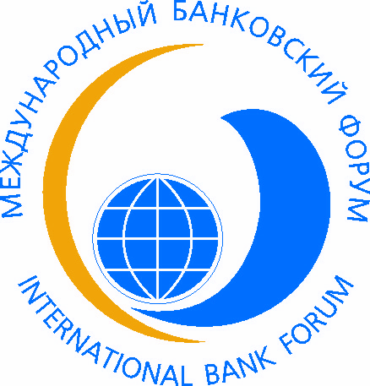  CОЧИ 2014 SOCHI | XII International  Banking Forum  «BANKS OF RUSSIA —  XXI CENTURY»
TENTATIVE PROGRAM

Day 1, September 3, 2014
Meeting at the airport, transfer, registration and accommodation of participants in hotel «Radisson Blu Paradise Resort & Spa»
19.00-20.00 Forum Opening Ceremony, Welcome Cocktail
20.00 Dinner
Day 2, September 4, 2014
8.00-9.00 Breakfast
09.00-9.30 Registration of participants(without accommodation in hotel)
09.30-10.00 Opening of conference “Models of development of the financial sector in the context of globalization: Russian and international practice”
10.00-11.30 First session «Current and strategic goals of the financial sector development of the Russian Federation for the period until 2020»

Topics for discussion:
- Macroeconomic conditions of the financial sector development : assessment of the current moment and possible development scenarios;
- Financial Market Development Strategy of Russia for the period until 2020;
- Financial sector as a factor of sustainable economic growth;;
- Interaction of the participants of the Russian financial sector to develop a national capital market
- Increasing the attractiveness of the Russian jurisdiction for doing business: legal aspects of deoffshorization;
- National Payment System: Problems and Solutions.
Q&A

11.30-12.00 Coffee-break

12.00-14.00 Second session “Enhancing of the stability of the national financial sector: challenges and solutions”
Topics for discussion:
- Systemic risks of the financial sector and ways to minimize them;
- Roadmap of the Russian financial sector stability increasing;
- State support of the financial sector stability: positive and negative effects;
- Measures to develop and modernize the infrastructure of the Russian financial sector;
- Topical problems of the Russian interbank credit market;
- "Parallel" banking activity and objectives to neutralize it.
Q&A
14.00-15.30 Lunch
17.00-24.00 Entertainment program at the "Galaxy Centre". Mountain tourism cluster "Krasnaya Polyana".

Day 3, September 5, 2014
8.00-9.00 Breakfast
10.00-12.30 Round Tables:

- “Strategies and models of the financial market participants sustainable development”
Topics for discussion:
- Strategies and models of the financial market participants sustainable development and way of their realizing;
- Business planning in financial institutions: searching for effective solutions;
- Risk Management in the business models and models of sustainable development;
- Sources of business processes financing;
- Banking business transformation: trends and international best practice;
- Interaction of the Bank of Russia and the financial market subjects on the principles of sustainable development.

- “Financial infrastructure improving and the formation of the national payment system: problems and solutions”
Topics for discussion:
- Legal aspects of the national payment system regulation ;
- Key directions of the Russian financial infrastructure improving;
- National payment system in the context of national economic security;
- National Payment Card: searching for optimal solutions;
- IT-technologies of the financial sector and trends of their development .
- “Availability and quality of financial services as a factor of economic growth of Russian regions”
- Development of financial services availability in various Russian regions;
- The system of financial services quality management : Russian and international experience;
- Standardization of banking services as a factor increasing their quality and availability;
- Trends of creation of territorial networks of banking services;
- Potential and prospects of complex branchless banking;
- Support of small and medium businesses in Russian regions: Problems and Solutions;
- Protection of financial services consumers and objectives to improve the financial literacy.

12.00-12.30 Coffee-break

13.00-14.30 Third session “Trends in regulation and supervision of financial institutions in the context of financial markets globalization”
Topics for discussion:
- Integration of regulation and supervision functions on financial market: Russia in the context of the current international practices and key challenges in the medium term;
- Consolidated supervision and practice of its implementation in the Russian financial sector;
- Systemically important financial institutions and approaches to regulation of their activities;
- Special aspects of non-credit financial institutions activities, their supervision and regulation;
- Special aspects of self-regulatory organizations activity in the financial sector;
- Problems of interaction between megaregulator and financial market participants.
Q&A

14.30-15.00 Closing remarks of the Forum
15.00-16.30 Lunch
16.30-20.00 Sport activities
20.45 Gala reception. Forum Closure
Day 4, September 6, 2014

Departure Day, Transfer to the airport

